**A**

**PROJECT REPORT**

**ON**   
  
**“DANCE ACADEMY SYSTEM”  
  
2017-2018  
  
  
  
SINHGAD COLLEGE OF COMMERCE**

**(AFFILIATED TO SAVITRIBAI PHULE UNIVERSITY & RECOGNISED BY GOV.OF MAHARASHTRA)  
  
UNDER THE GUIDANCE OF  
  
Mrs. RAJSHREE SATDIVE**

**SUBMITTED BY:  
  
JAI NAGDA**

**SHRADHA MEMANE  
  
TYBBA (CA)**

**SEM VI**



**SINHGAD COLLEGE OF COMMERCE**

**(AFFILIATED TO SAVITRIBAI PHULE UNIVERSITY & RECOGNISED BY GOV.OF MAHARASHTRA)**Kondhwa(Bk),Kondhwa –Saswad Road,Pune-411048  
  
**CERTIFICATE  
THIS IS TO CERTIFY THAT**

**Mr.JAI NAGDA**

**Ms.SHRADHA MEMANE**

**OF FINAL YEAR BACHELOR OF COMPUTER APPLICATIONS HAVE SUCCESSFULLY COMPLETED THE PROJECT REPORT ON  
  
DANCE ACADEMY SYSTEM  
  
IN SATISFACTORY MANNER FOR FULFILLMENT OF BACHELOR OF COMPUTER APPLICATION IN SAVITRIBAI PHULE PUNE UNIVERSITY, PUNE**

**PROJECT GUIDE** **PRINCIPAL** **EXTERNAL** **EXAMINER**

**ACKNOWLEDGEMENT**

We wish to thank for Mrs. RAJSHREE SATDIVE for their valuable guidance which is very much needed. We are very grateful to our project coordinate who supported Us through-out the project. Without her help and full support our project would Not have been completed in time. we would like thank You to Our HOD. MR.PRAMOD BORA giving Us continuous support and encouraged to complete the project Successfully.

|  |  |  |
| --- | --- | --- |
| 1. | Introduction | 5 |
| 2. | Scope of system | 6 |
| 3. | Existing System | 9 |
| 4. | Proposed System | 10 |
| 5. | Fact Finding Technique | 12 |
| 6. | Technical Requirement &  Hardware Requirement | 14 |
| 8. | Design Specification  ER Diagram  Data Flow Diagram  Class Diagram  Use Case Diagram | 16  To  24 |
| 9. | Data Dictionary | 23 |
| 10. | Screen Layout | 30-39 |
| 11. | Data Report | 40-44 |
| 12. | Limitation | 45-46 |
| 13. | Bibliography | 50 |

*INTRODUCTION*

**INTRODUCTION TO SYSTEM**

Dance Academy system software provides dance studio, a software solution of Trainer Detail, Batch Detail Student Admission , etc.

This dance academy system provides:-

* Student Admissions
* Trainer Details
* Course Details
* Batch Details
* Student Details
* Receipts
* Report Detail

Dance Studio Management offers dance studios a system to organize

and manage their content, batchs, student detail and Trainer etc

this system will not only provide a good marketing tool but also as a Good management tool.

**Scope of System**

We have computerized the manual system for reducing complexity of the records of transaction & account transaction. In our software we have provide separate section i.e. Trainer, Course , and Batches so that they can maintain records easily.

The “DANCE ACADEMY SYSTEM” provides the following facilities.

**A} Administrator’s login for security purpose**:-

1. Provides password lock facility.

1. Only authorized user can access system.

**B} Trainer details**:-

1. Add Trainer Details.

2. Modify Trainer Details.

3. Display Trainer Details.

**C} Course Details**:-

1. Add **} Course** Details.

2. Modify} **Course** Details.

3. Display **} Course**  Details.

**D} Batch Details:-**

1. Add **Batch** Details.

2. Modify **Batch** Details.

3. Display **Batch** Details.

**E} Admission Details:-**

1. Add Details.

2. Modify Details.

3. Display Details

**Existing system**

* In the existing system , storing data, information and Documentation like file has lots of manual work.
* This system will Maintain student details, Course details, trainer details, Admission details etc. which stores the Information about the student.
* We have used unique layouts and pictures to develop a System which provides better instruction than the existing System.

**Proposed System**

* Considering the needs and requirements of the existing System and amount of manual work to be done, the following System is proposed which is capable to maintain a lot of data And information , the proposed system is a better solution to Drawbacks of the existing system.
* This system will Maintain student details, Course details, trainer details, Admission details etc. which stores the Information about the student.
* We have used unique layouts and pictures to develop a System which provides better instruction than the existing System.

***ANALYSIS***

**Fact Finding Technique**

To design the system or to solve any problem related to the system. We must study about the system deeply. To get deeper knowledge about system we should examine the existing system frequently, ask question to different uses ,get information about the new changes related to system etc.

* **Record Review :-**

In record review analyst examine information that has been recorded about the system, about user record inspection can be Performed at the beginning of the study as an introduction or it Can be performed after the study as the basis for comparing Actual operation with the record indicate should be happening.

* **Interviews :-**

Interview are useful in collecting data information

from individuals or group. Asking how work is conducted what are the requirement to the different user.

* **Questionnaires :-**

Questionnaires are used to collect information about various aspects of the system from large number of people standardized question format used.

The open response questionnaires are used to learn about the opinion, feeling, any general experience about the Whole process.

* **Observations :-**

We get the information about system which help us to Understand the system.

Observation of the existing system provides the information about the activities carried out, processing time and the human resource involved.

**FEASIBILITY STUDY**

Feasibility study is conducted once the problem is clearly understood. Feasibility study is a high level capsule version of the entire system-analysis and design process. The objective is to determine quickly and at the minimum expense how to solve the problem and to determine the problem which is solved. The system has been tested for feasibility in the following ways.

* Technical feasibility
* Operational feasibility
* Economical feasibility

**Technical feasibility :-** The study of function performance and constraints may effect the ability to achieve an acceptable system so, that necessary function and performance are achieved within the constraints uncovered during system analysis. The software developed for the automation of Dance Academy System is platform independent and has predefined functions and constraints such as to locate the charges, validating functions etc., so that project is technically feasible

.  
**Operational feasibility :-** The purpose of this project is to develop software named Dance Academy which facilitates quick registration process. The activities of the system such as data entry, information retrieval, updating and deleting of records from various tables are made easy. All the operators of this project are trained in this area. So this project is operational feasible.  
  
 **Economical feasibility :-**

Economic analysis includes a broad range of concerns that include cost benefit analysis, long term cooperative income strategies, cost of resources needed for development .In existing they had to maintain a large number of books/registers.

**Hardware & Software Requirement**

Hardware Requirements:-

* Processor: Windows 98/XP/7/10/8
* RAM: 512 MB
* Hard Disk: 2.5 Gigabyte On Installation Drive, Which Includes 1GB On System Drive.

Software Requirements:-

* Front-End:- Sun Microsystem Java-8
* Back-End:- MySQL 5.0

This system was developed under window 10. It is complete with all 64-bit versions of windows operating system.

Windows is a popular and largest used operating system in the world because it is easy to understand and provides an easy interface to users.

**SYSTEM DESIGN**

**Entity Relationship Diagram**

in

Trainer

T_address

T_id

T_name nonono

**1** m

Name

1

Address

C_no

Institute

Have

Has

Time

sid

**1**

Sname

Email id

**m**

Student

S_address

**1**

Age

To

Take TaTake

Select

Has Has

Time

Strengths

Batch ty

Batch no No

T_Name

Style

Time

DanceStyle

Address

C_no

Name

DOB

Dance Style

Batches

Admission

1

m 1 1 1

Has HHas Has Has Has

**First Level DFD**

**Institute**

**InstituteDetails**

**1.0**

1.1

**Enquiry**

**Student**

**Student id**

1.2

2.0

**Registration**

**Admission**

**Admission Process**

1.3

444 3.0

**Trainer**

**Give Receipt**

**Trainer**

1.4

Trainer detail

**Second Level DFD**

Create

Admission

Process

2.1

Academy

Accept

AcceptAdmission

Update

Info

2.2

Dance Trainer

All info accept

Accept info

Select, Delete

Entry Student

**Use case Diagram**

Add Student Data

Add Dance style

Fill Admission Form

Add Batch Details

Save in Database

Add fees Details

Check Fees Mode

Fee Confirmation

Save update in database

Admission Confirm

Login

**Context level DFD**

Academy

Student

Dance

Admission

System

0.0

0

See all information Check Status

Details

Add Confirmation

Dance Style & Batches

Admission

**DATA FLOW DIAGRAM**

Informaton

Purchase Master

Purchase

Shoes bill

1.0

Purchase

Of

Shoes

Rupees

Supplier

Supplier

Information

Supplier Master

Stores

2.0

Billing

Of

Shoes

Customer

Information

Customer Master

Shoes bill

Customer

Rupees

Billing

Information

Billing Master

Details

Supplier Master

3.0

Report

Generatia

Admin

Customer Master

**DATA DICTIONARY**

We are developing the software for “Dance Academy System”. We collect all the information of day to day transaction as per their requirement we try to provide all of it

While making this software we create following tables in MySQL

* Batch Details Table
* Course Details Table
* trainer Details Table
* Fees Details Table
* Receipt Details Table
* Student admission table
* Admission details table

.

2. Class Diagram:

Admission System

Admission id

Student name

Dance Style

Trainer

Student Time

Fee

Register

1 1

* *

Institute

Institute id

Name

Phone no

Address

Add Student

Student admission

Delete Dance Style

Add Batches

Delete Batches

View Dance Style Details

View Student Details

Student

Student id

User pass

Name

Phone no

Fees

Dance Style

Batch time

Take Admission

m

Dance Style

Dance id

Student id

Institute id

Name

Fees

Dance trainer

Batch

Batch id

Batch Time

Name

Update

Delete

Search

Start date

m1 1

m

**BATCH DETAILS TABLE**

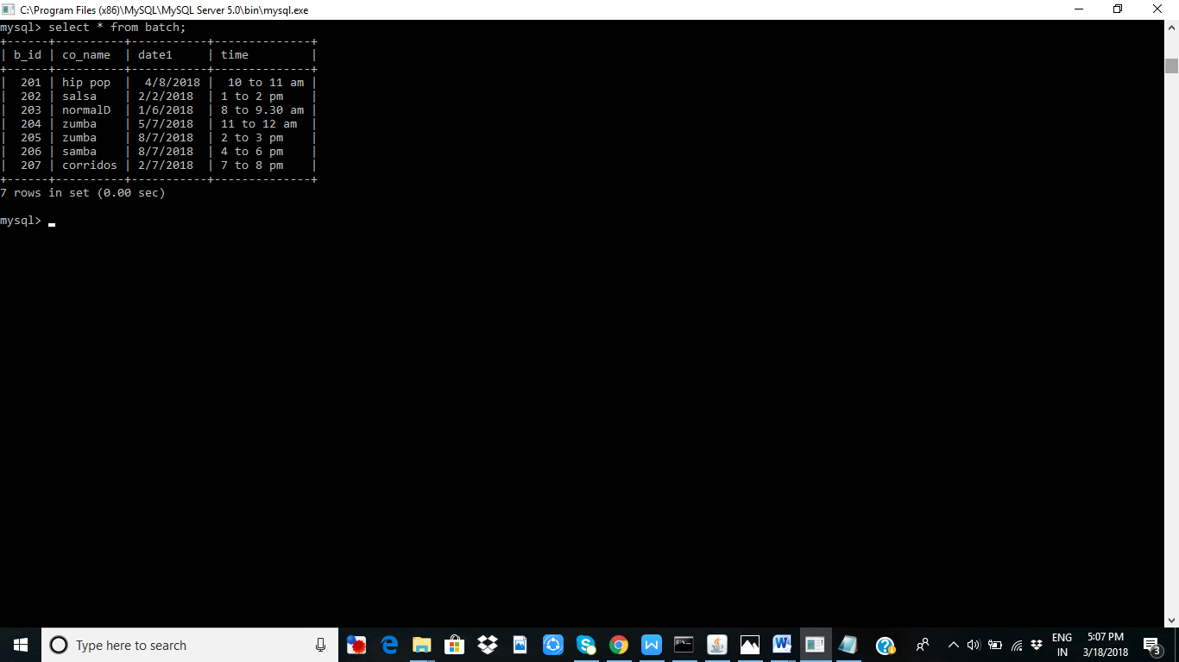

**COURSE DETAIL TABLE**

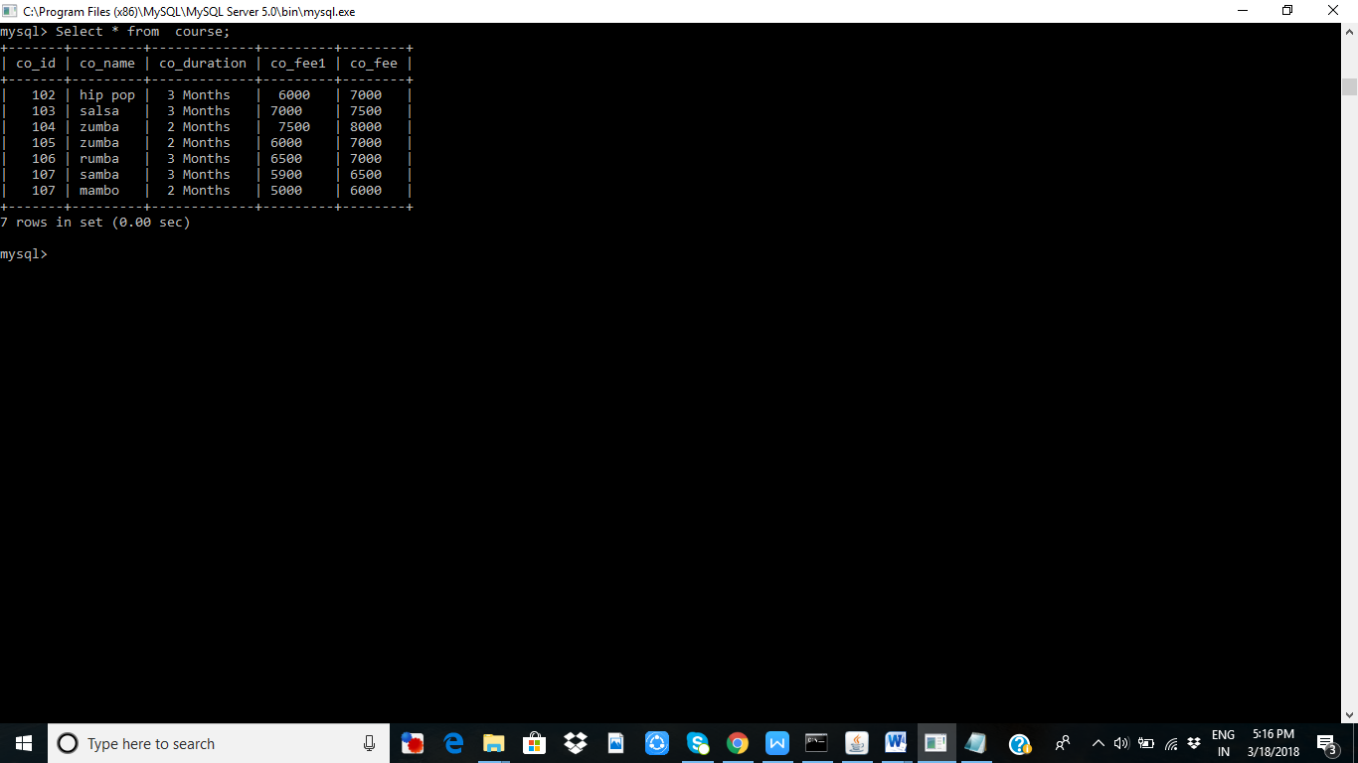

**Enquiry Table Detail**



**BILL TABLE**

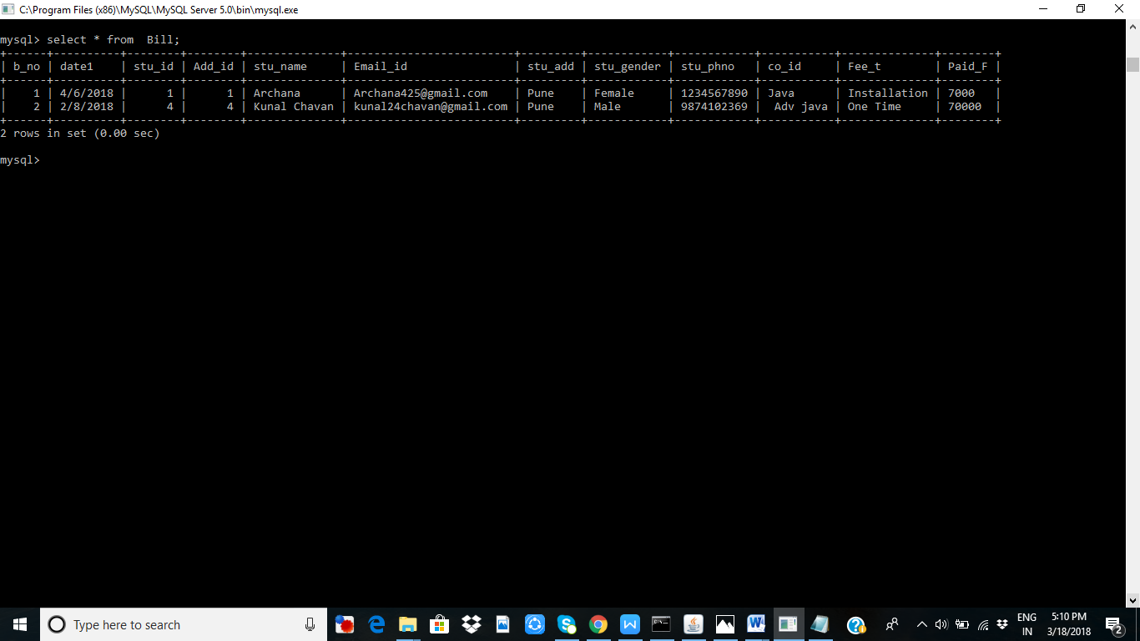

**Admission Table**



**FORM DESIGN**

**LOGIN FORM**

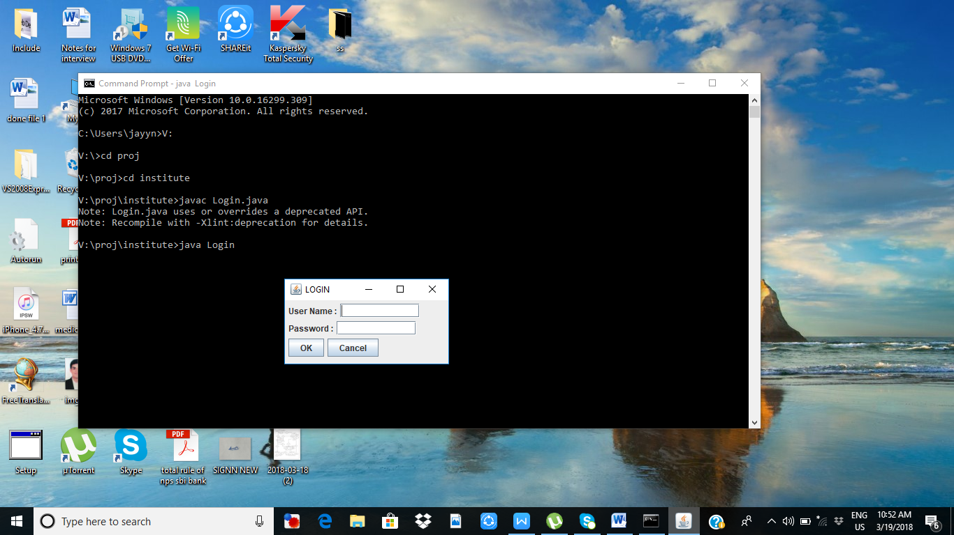

**MAINMENU FORM:-**

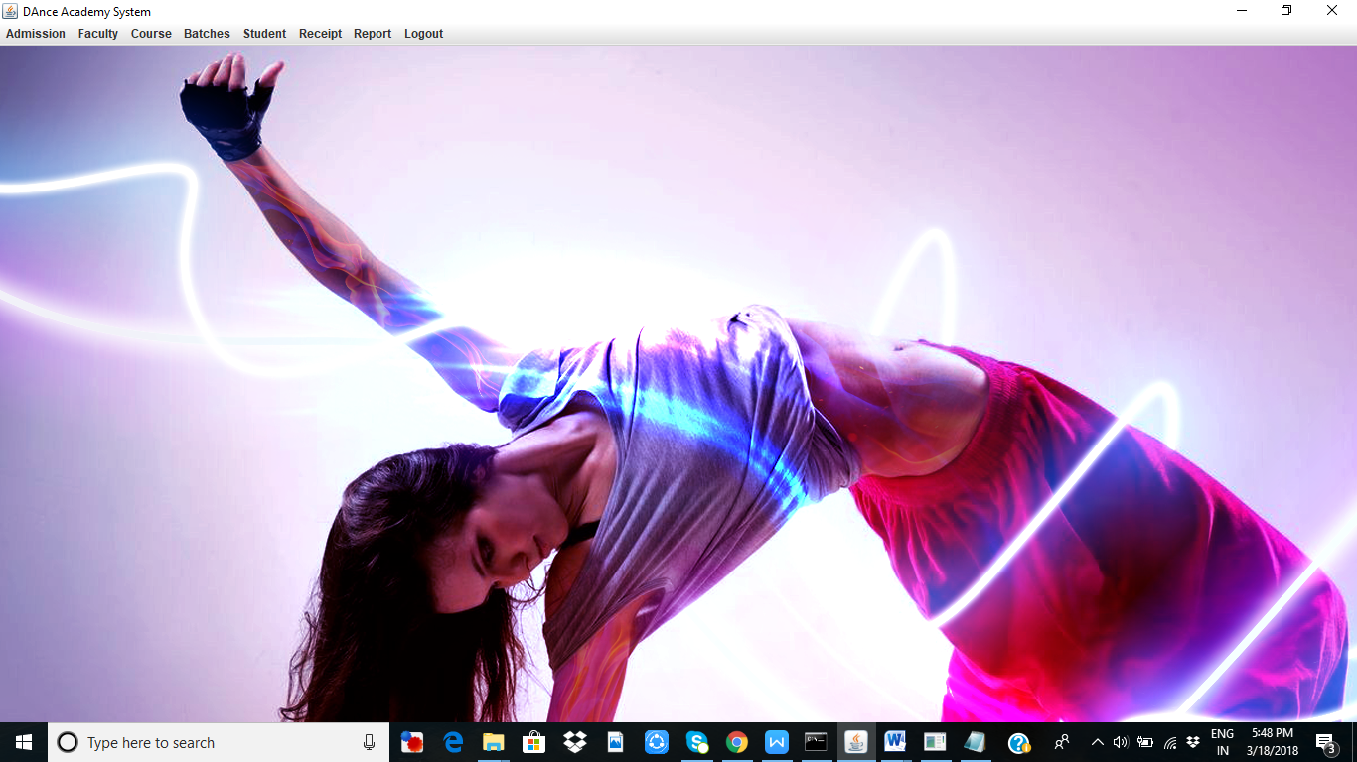

**ENQUIRY FORM :-**

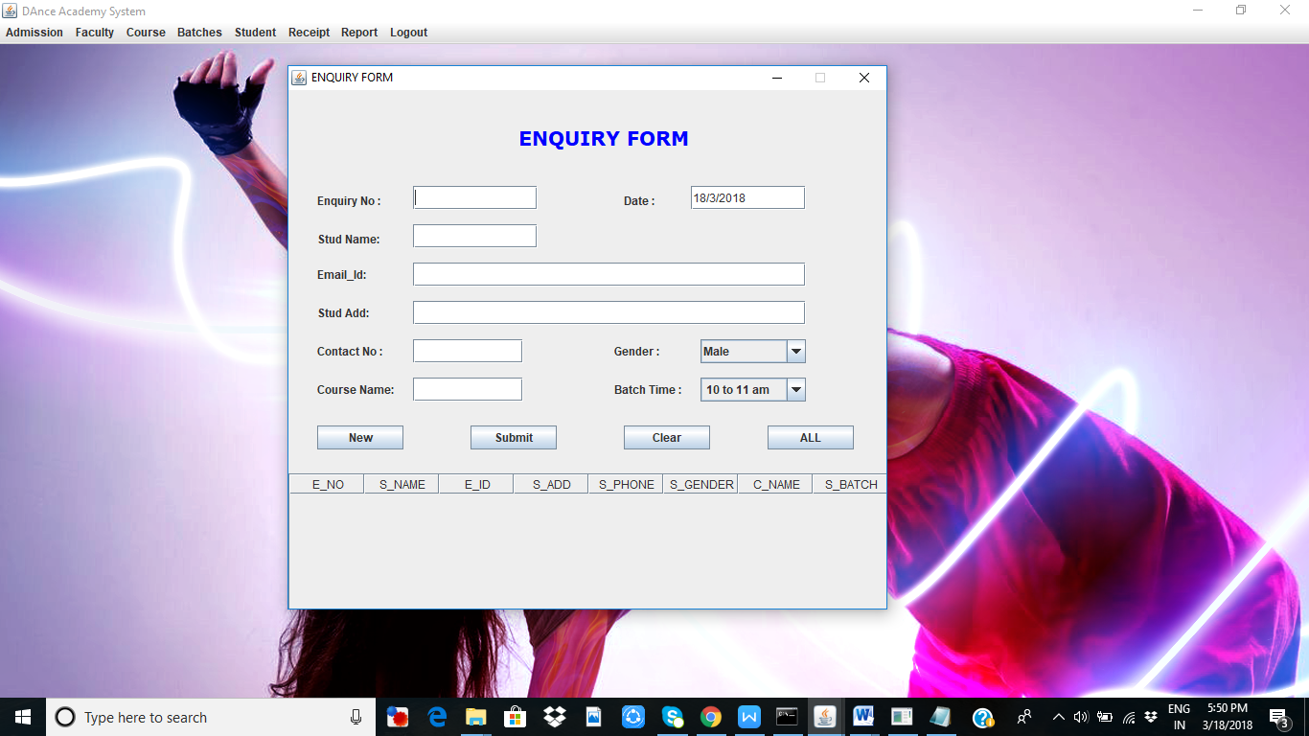

**COURSE DETAIL FORM**

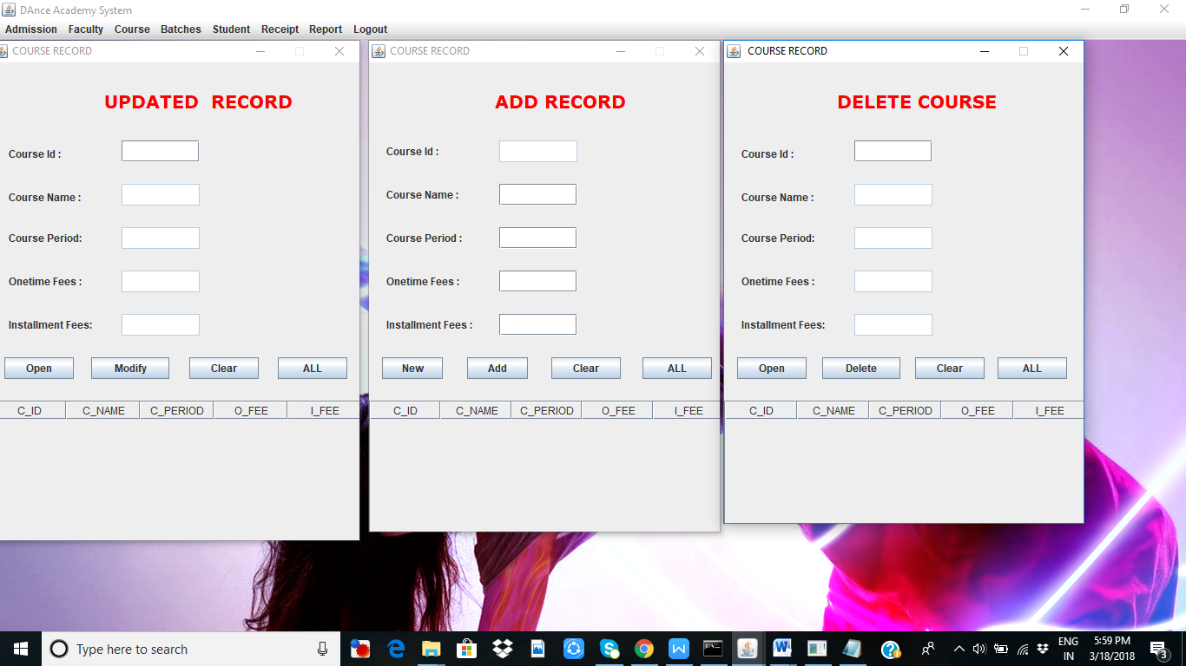

**STUDENT ADMISSION FORM**

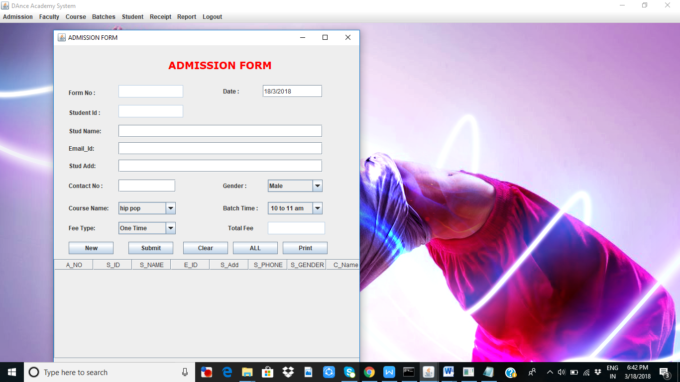

**TRAINER DETAIL FORM**

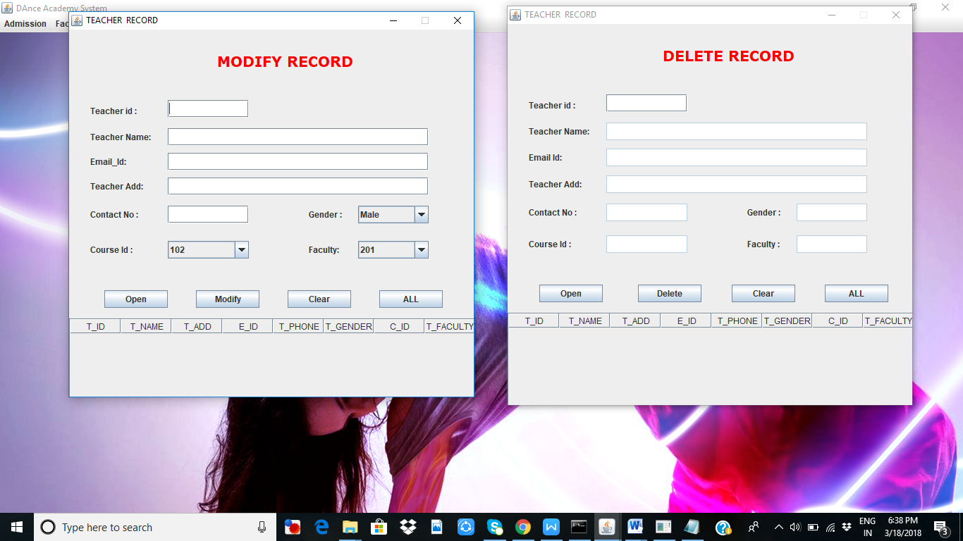

**TRAINER DETIAL FORM**

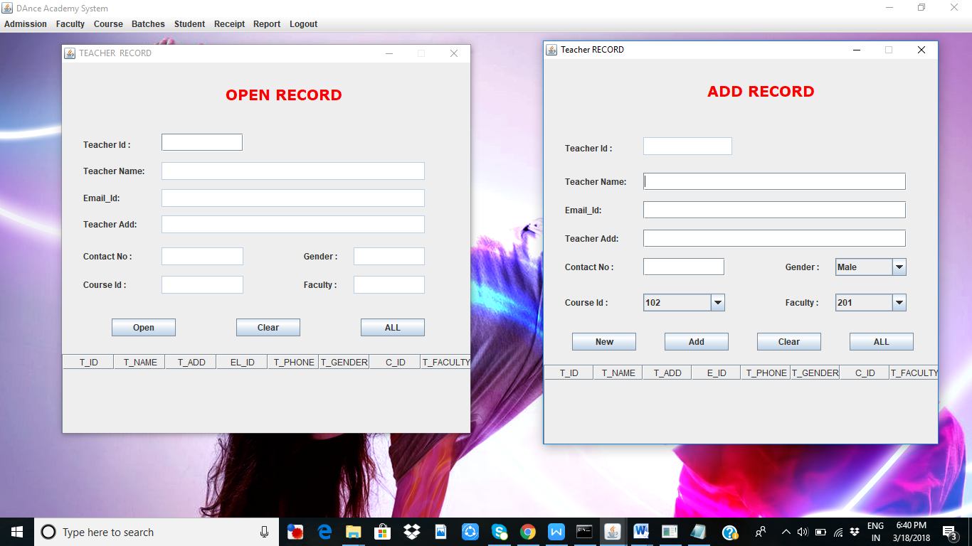

**BATCH DETAIL FORM**

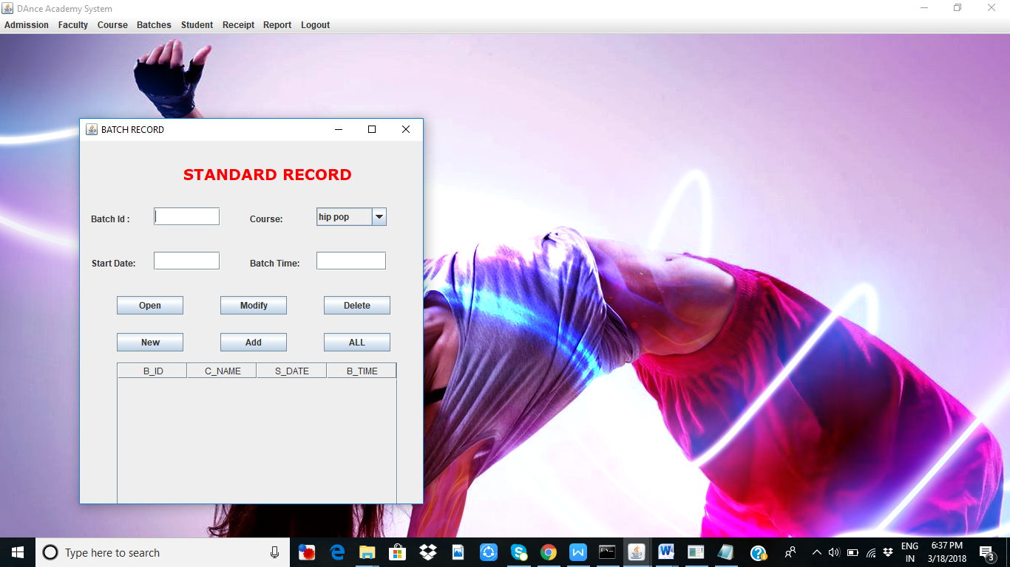

**STUDENT RECEIPT FORM**

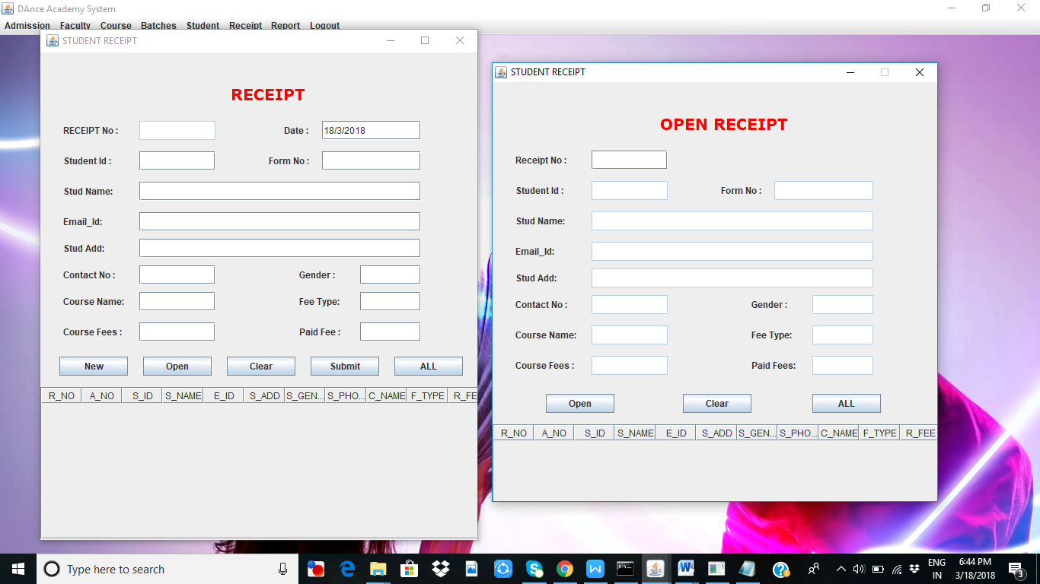

**REPORTS**

**ADMISSION REPORT**

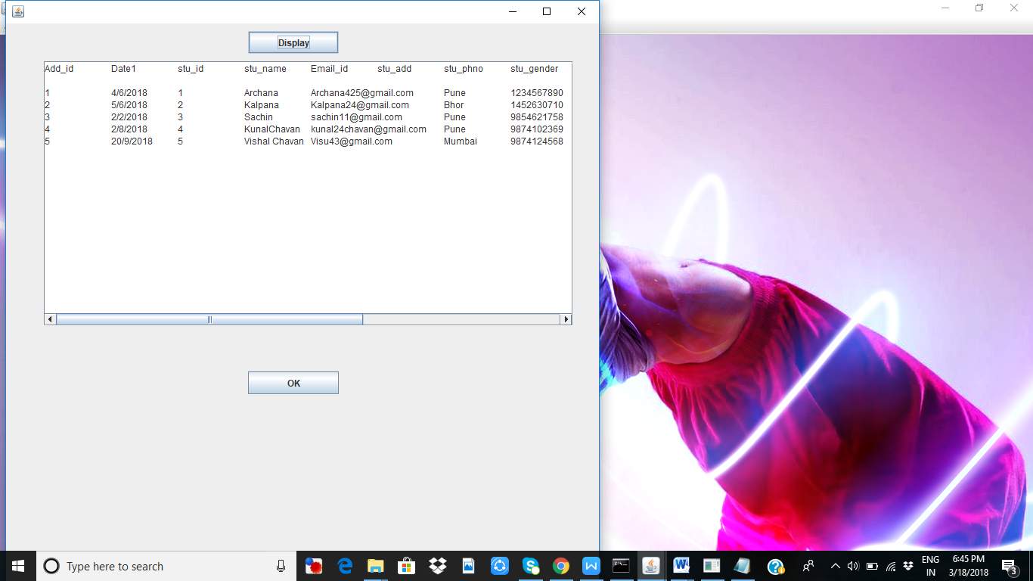

**COURSE REPORT**

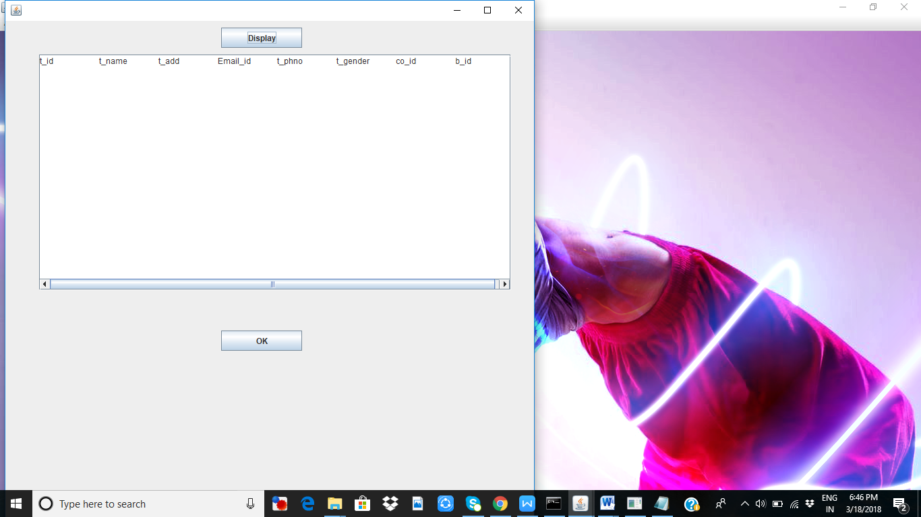

**ENQUIRY REPORT**

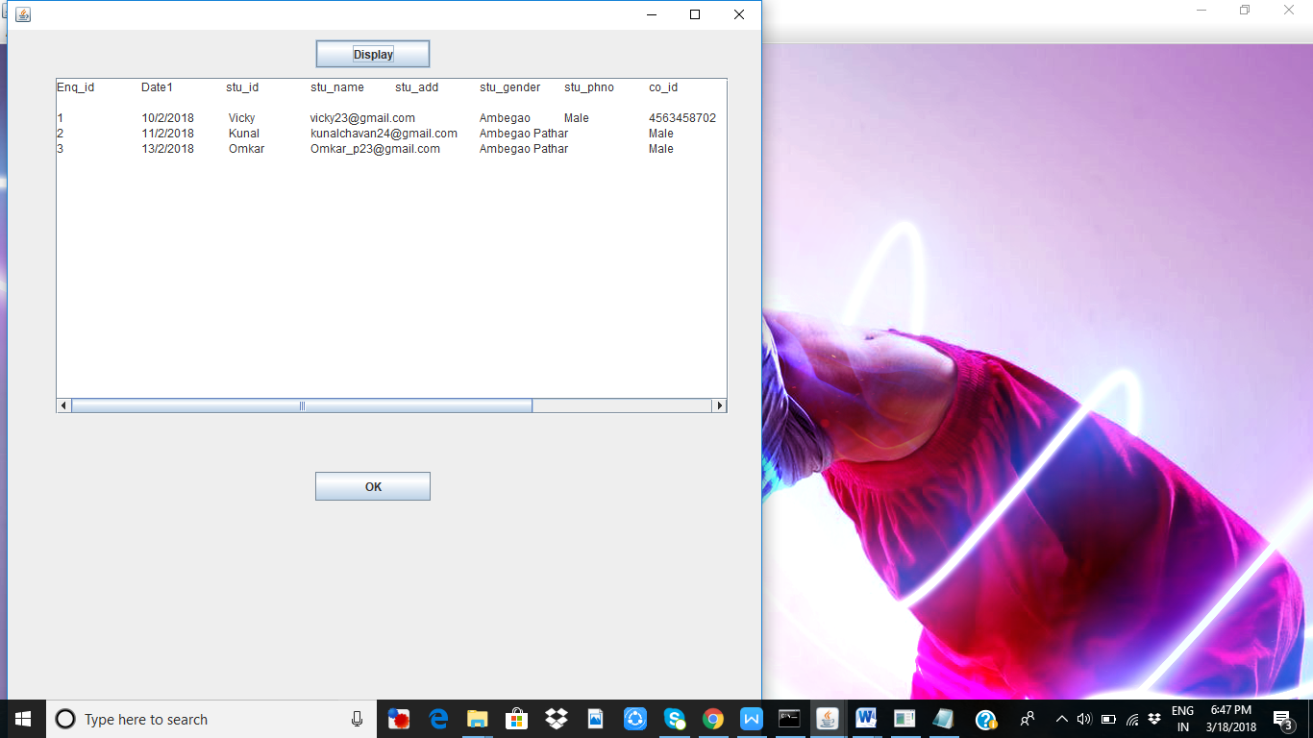

**TRAINER REPORT**

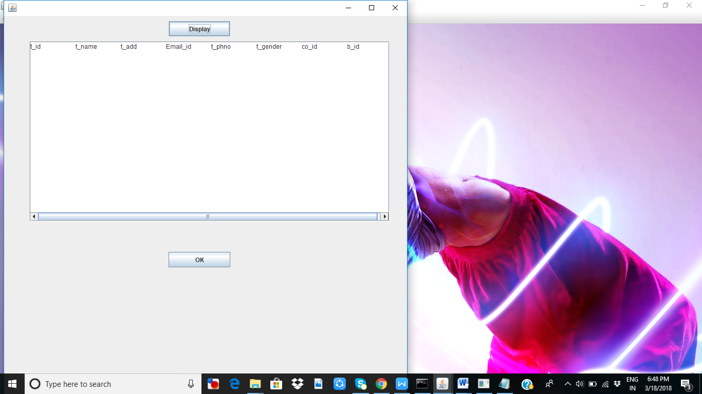

**ADVANTAGES & LIMITATIONS**

**ADVANTAGES:-**

This system is to allow better viewing of information .

Administrator has the full authorization of the system.

Management will no longer need to go through papers of work and documentation which is time consuming.

Viewers will have an easy accessibility to all information of the dance academies.

All information will be easily found from the internet.

**LIMITATION**

Limitation of the project is that only specific Institute are Provided. Hence there is a limit in the selecting Institutes.

Updating Institute or adding new Institute is a tedious job. It does not cover all the features involved in the admission system.

Backup has to be maintained in order to prevent loss of data during system crash.

The database has to be regularly updated to add new academies. This is a very tedious job

**FUTURE ENHANCEMENT**

**Future Enhancement**

The Dance management is a system which is useful for the Admin to maintain his/her Acadamy transactions.

In this system some facility are as follows:

* It is very distributed system.
* They are web base system

**BIBLOGRAPHY**

1. JAVA in

Computer Lab in Collage

2. Analysis & Design of Information

Nirali Publication

3. ADV JAVA

Tech-Mach Puclication

**Website:-**

* [www.Google.com](http://www.Google.com)



**SINHGAD COLLEGE OF COMMERCE**

**(AFFILIATED TO SAVITRIBAI PHULE UNIVERSITY & RECOGNISED BY GOV.OF MAHARASHTRA)**Kondhwa(Bk),Kondhwa –Saswad Road,Pune-411048  
  
**CERTIFICATE  
THIS IS TO CERTIFY THAT**

**Mr.JAI NAGDA**

**OF FINAL YEAR BACHELOR OF COMPUTER APPLICATIONS HAVE SUCCESSFULLY COMPLETED THE PROJECT REPORT ON  
  
DANCE ACADEMY SYSTEM  
  
IN SATISFACTORY MANNER FOR FULFILLMENT OF BACHELOR OF COMPUTER APPLICATION IN SAVITRIBAI PHULE PUNE UNIVERSITY, PUNE**

**PROJECT GUIDE** **PRINCIPAL** **EXTERNAL** **EXAMINER**



**SINHGAD COLLEGE OF COMMERCE**

**(AFFILIATED TO SAVITRIBAI PHULE UNIVERSITY & RECOGNISED BY GOV.OF MAHARASHTRA)**Kondhwa(Bk),Kondhwa –Saswad Road,Pune-411048  
  
**CERTIFICATE  
THIS IS TO CERTIFY THAT**

**Ms.SHRADHA MEMANE**

**OF FINAL YEAR BACHELOR OF COMPUTER APPLICATIONS HAVE SUCCESSFULLY COMPLETED THE PROJECT REPORT ON  
  
DANCE ACADEMY SYSTEM  
  
IN SATISFACTORY MANNER FOR FULFILLMENT OF BACHELOR OF COMPUTER APPLICATION IN SAVITRIBAI PHULE PUNE UNIVERSITY, PUNE**

**PROJECT GUIDE** **PRINCIPAL** **EXTERNAL** **EXAMINER**